Table of Contents:
- Introduction
- Diagrams
- Prototype + GitHub Link
- Use Cases 1-21
- Conclusion

Introduction
This project presents FASAM, a web-based prototype for a centralized fire and security alarm management system for zoned buildings. The system monitors fire and security sensors, identifies affected zones, records alarm events, and supports operator decision-making through a control-area interface. It also models automated responses, including emergency notification, evacuation indicators, audible alarms, door locking, zone isolation, sprinkler activation, and electrical shutdown when safety conditions permit. The accompanying requirements, specifications, use cases, and diagrams define how FASAM should behave under-staffed, unmanned, fire, security, and combined incident scenarios, while prioritizing human safety, reliability, traceability, and controlled system evolution throughout development lifecycle.

Diagrams
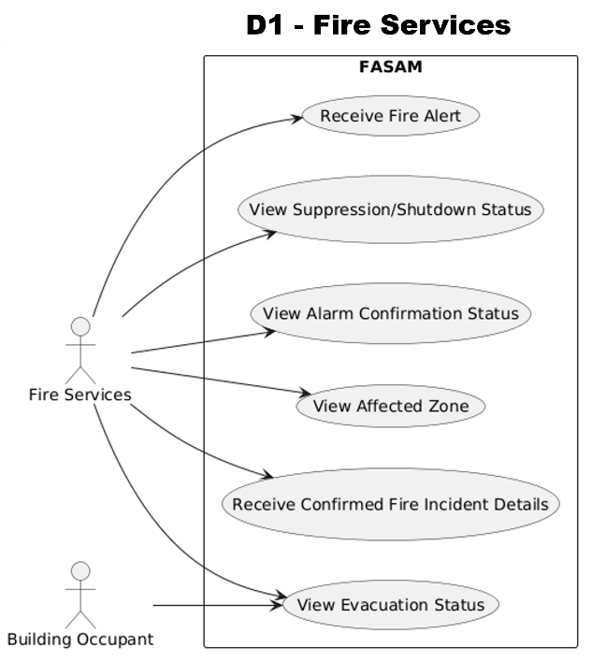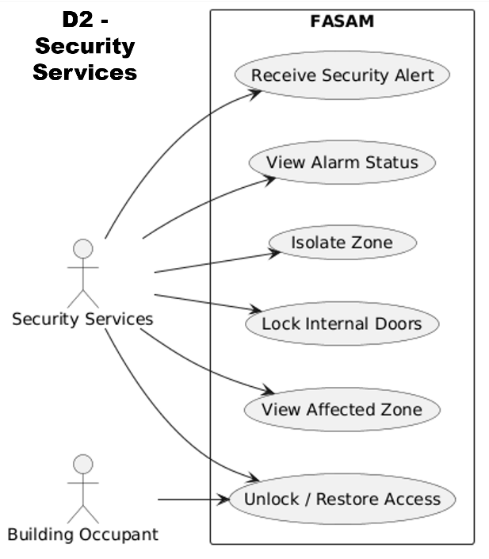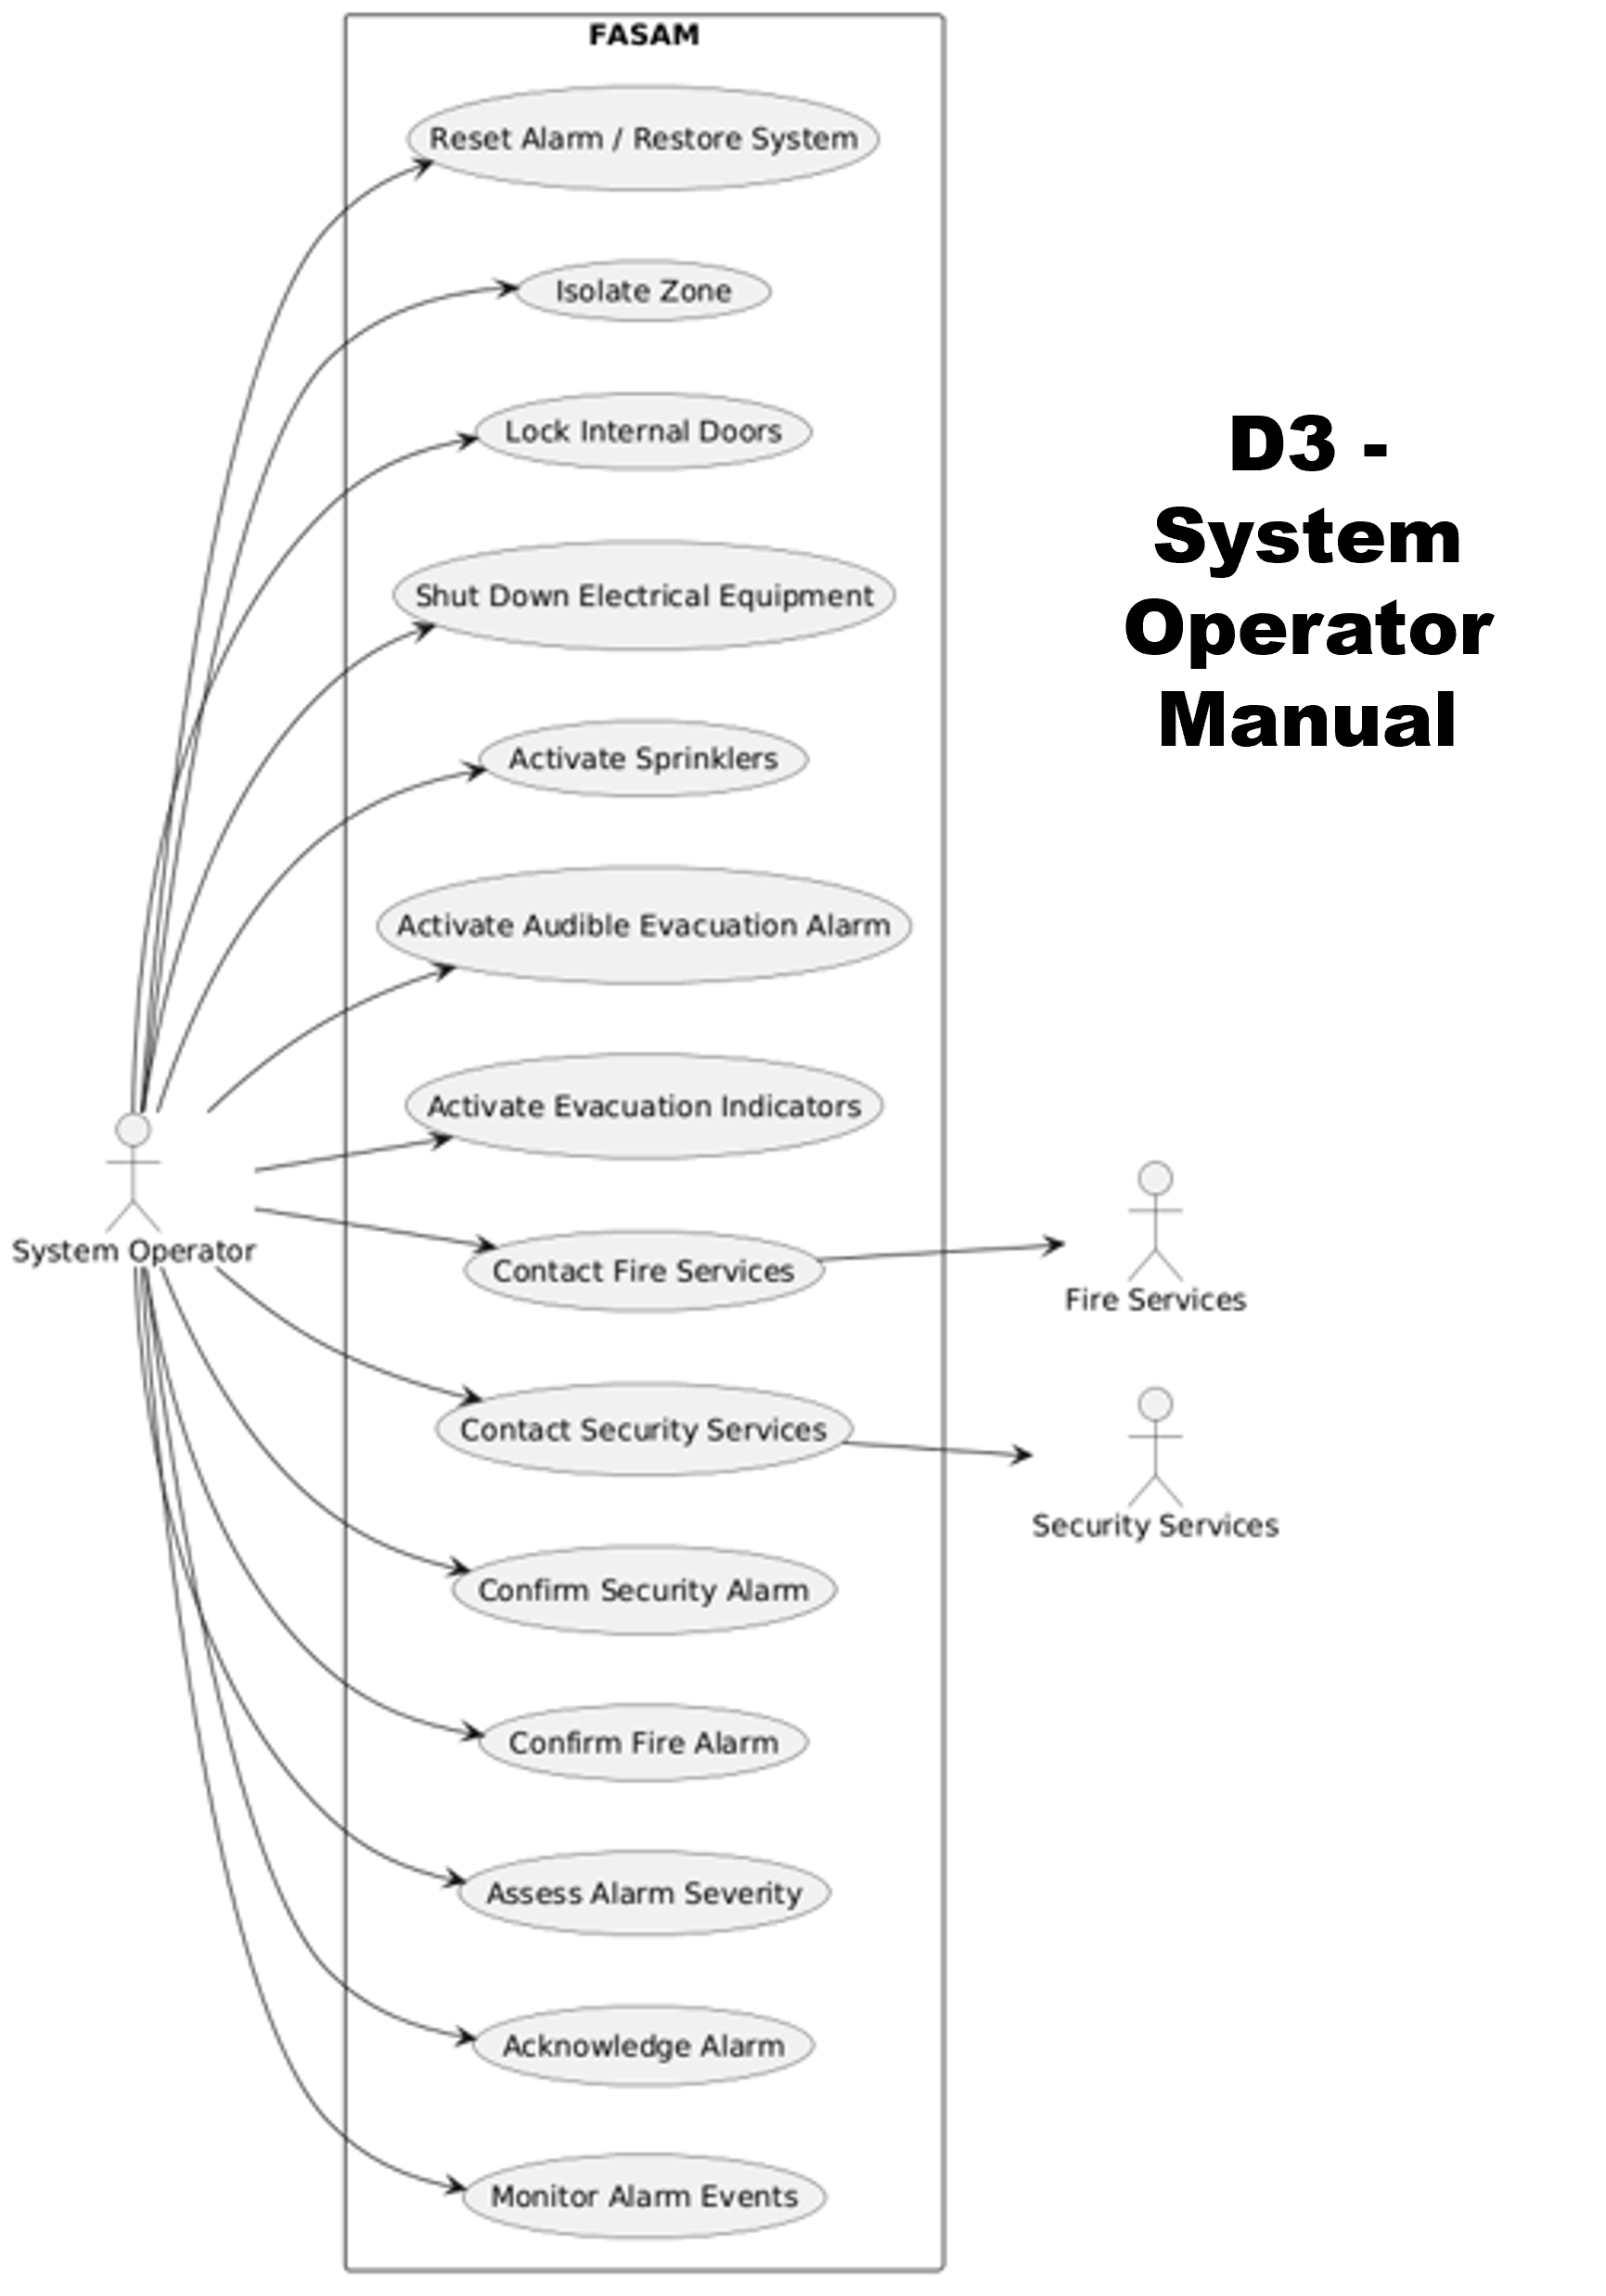
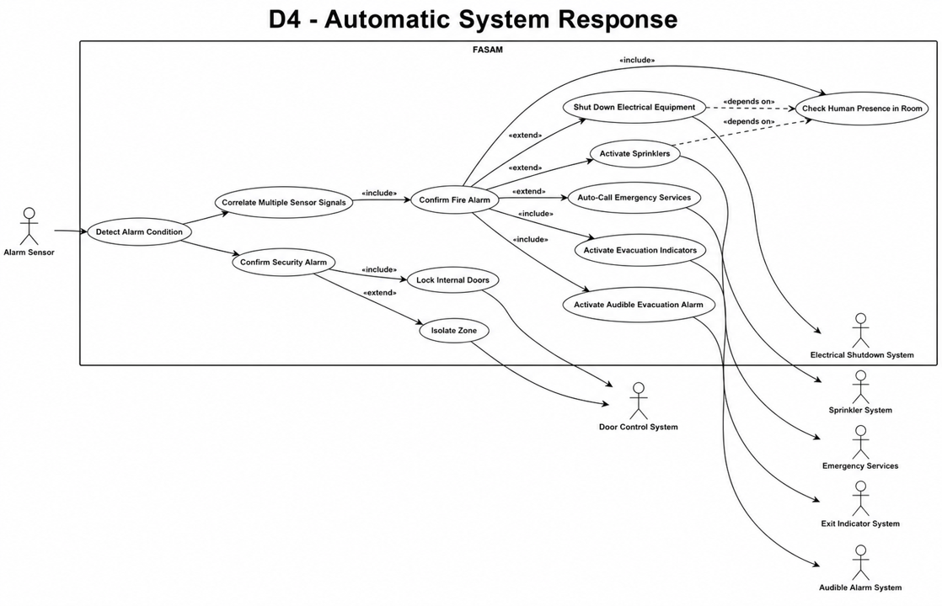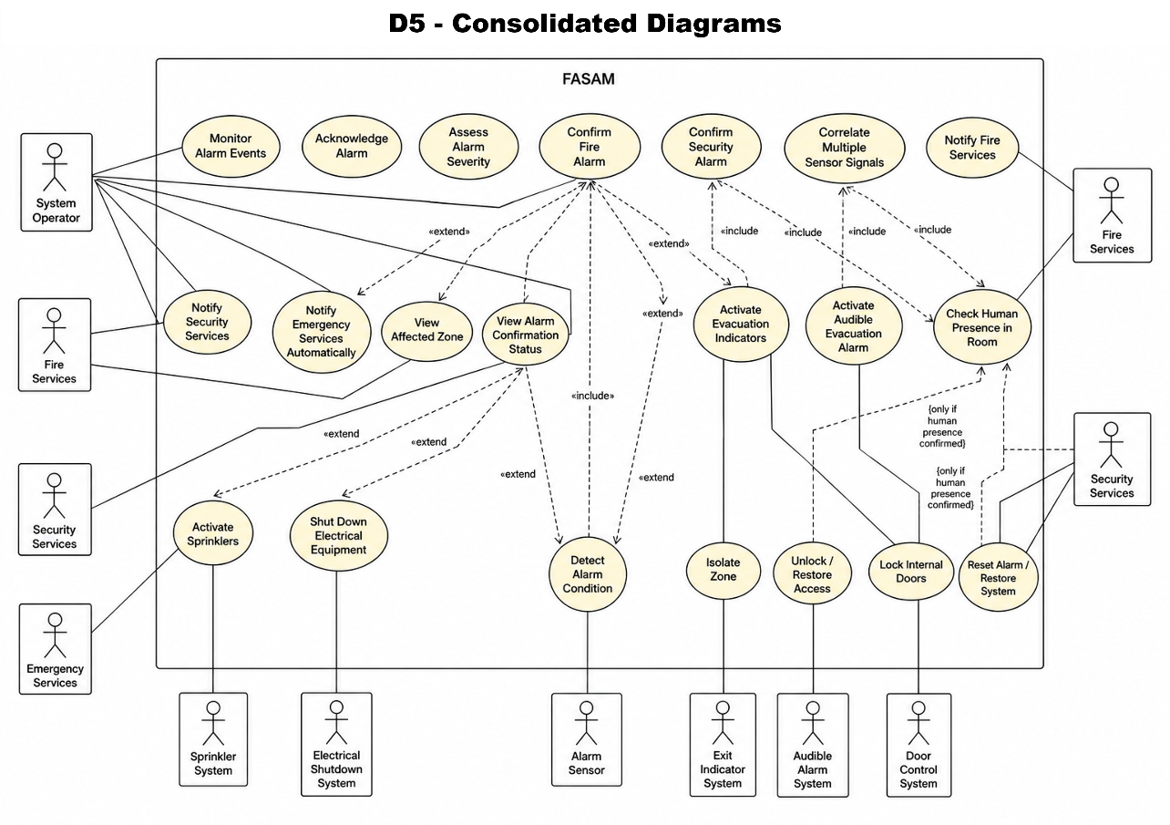

Prototype + GitHub Link: https://github.com/StudentPerson101/COM5011_SOFTWARE_ENGINEERING_CW1
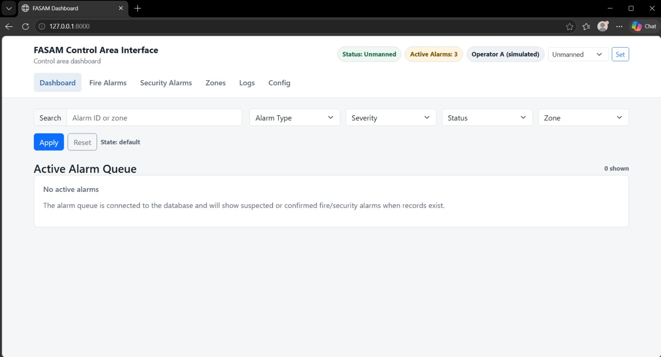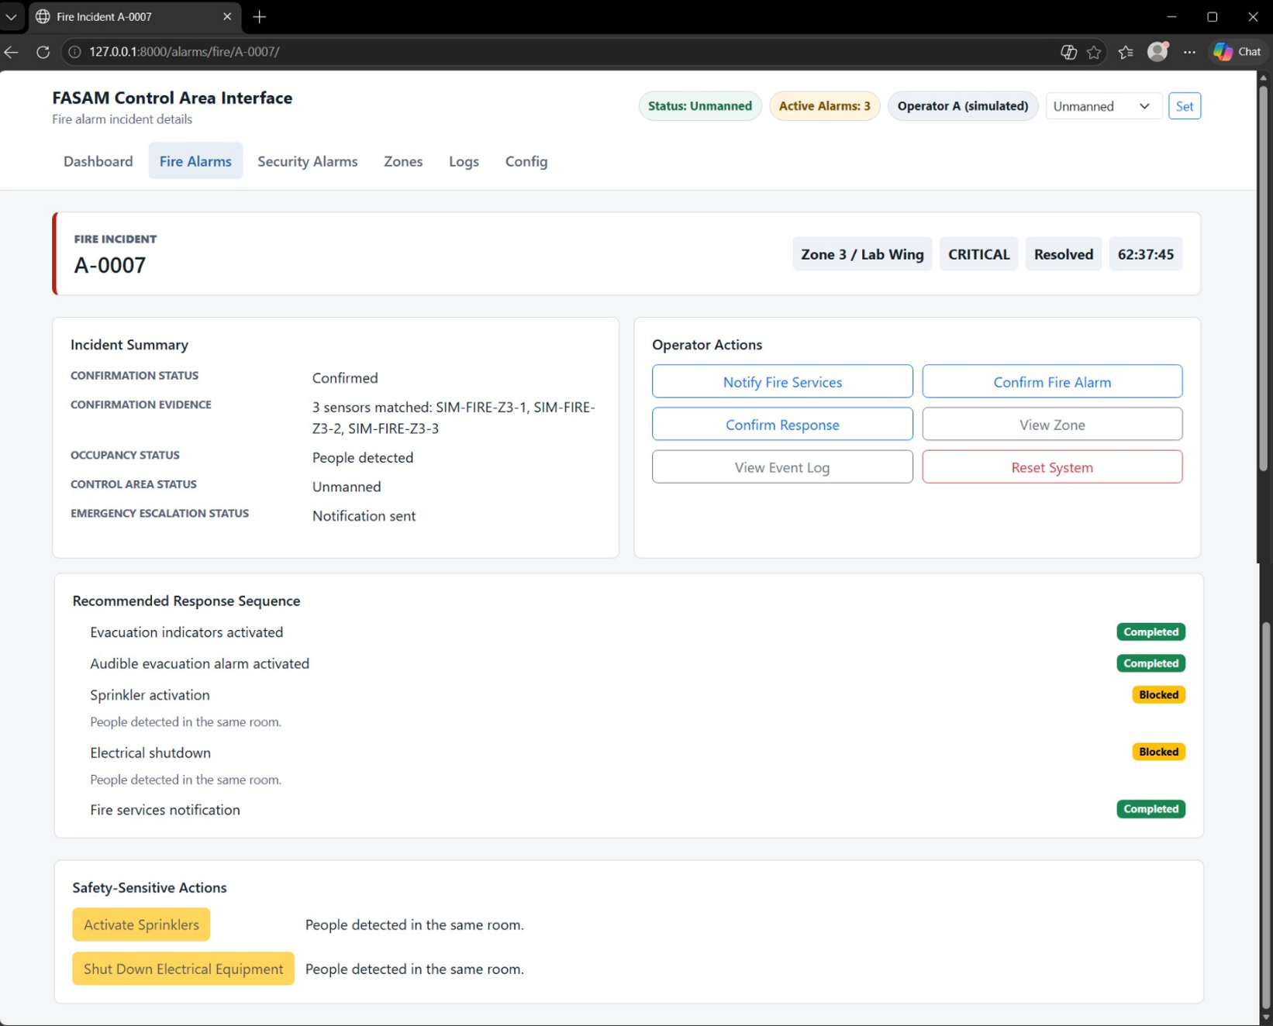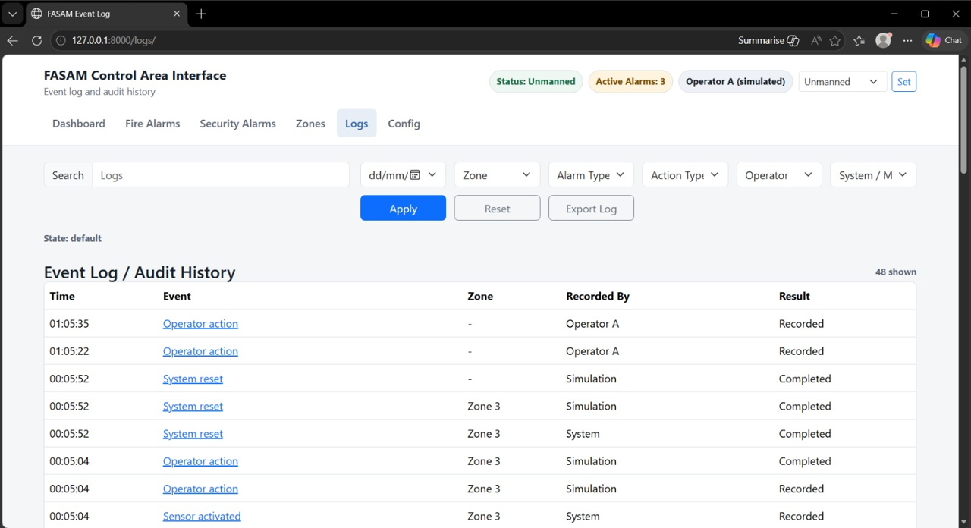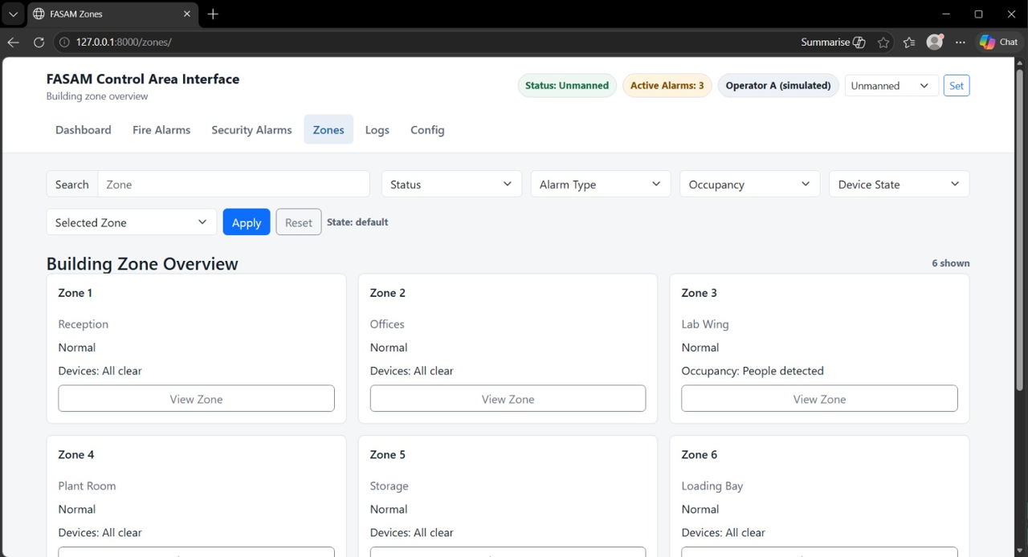

Use Case 1. Monitor Alarm Events. The primary actor is the System Operator. The goal is to observe incoming fire and security alarm events from all building zones. The precondition is that FASAM is running and connected to sensors. The main flow begins when the system receives event data from sensors. The event then appears on the operator display. The operator reviews the zone, alarm type, and current status. The postcondition is that the alarm event is visible for action or follow-up.

Use Case 2. Acknowledge Alarm. The primary actor is the System Operator. The goal is to mark an alarm as seen and being handled. The precondition is that an alarm event exists. The main flow begins when the operator selects an alarm. The system then records the acknowledgment time and the operator’s identity. The postcondition is that the alarm is marked as acknowledged.

Use Case 3. Assess Alarm Severity. The primary actor is the System Operator. The goal is to determine whether the alarm is potentially serious. The precondition is that an alarm has been raised. The main flow begins when the operator checks the alarm type, affected zone, and corroborating inputs. The operator then judges the severity using system information. The postcondition is that the alarm is classified for either manual or emergency response.

Use Case 4. Confirm Fire Alarm. The primary actors are the System Operator and FASAM. The goal is to establish that a fire condition is genuine before escalation and response. The precondition is that a fire-related alarm condition has been detected. The main flow begins when the system or operator reviews the evidence. Multiple sensor detections or manual confirmation then validate the fire. The alarm state changes to confirmed fire. The postcondition is that fire-response actions may proceed.

Use Case 5. Confirm Security Alarm. The primary actors are the System Operator and FASAM. The goal is to establish that a security alarm condition is valid. The precondition is that a security-related alarm condition has been detected. The main flow begins when the system or operator reviews the triggering event. If valid, the alarm state changes to a confirmed security incident. The postcondition is that security-response actions may proceed.

Use Case 6. Correlate Multiple Sensor Signals. The primary actor is FASAM. The goal is to use multiple sensor activations to support confirmation of a fire event. The precondition is that one or more sensors have triggered. The main flow begins when the system collects signals from detectors in the same or related zones. The system then compares the time, type, and location of the triggers. If the correlation threshold is met, confirmation evidence is produced. The postcondition is that the fire confirmation decision is supported.

Use Case 7. Notify Fire Services. The primary actors are the System Operator and Fire Services. The goal is to pass a confirmed or serious fire incident to fire responders. The precondition is that the fire alarm has been confirmed or judged sufficiently serious. The main flow begins when the operator or system compiles incident details. A notification is then sent to fire services. Fire services receive the zone and status details. The postcondition is that an external fire response is initiated.

Use Case 8. Notify Security Services. The primary actors are the System Operator and Security Services. The goal is to pass a confirmed security incident to security responders. The precondition is that the security alarm has been confirmed or judged actionable. The main flow begins when the operator or system compiles incident details. A notification is then sent to security services. Security services receive the zone and status details. The postcondition is that a security response is initiated.

Use Case 9. Notify Emergency Services Automatically. The primary actor is FASAM. The goal is to automatically call emergency services when the control area is unmanned and the alarm is potentially serious. The preconditions are that a serious alarm has been detected and the control area is unmanned. The main flow begins when the system detects the unmanned control state. The system then determines whether the alarm meets the seriousness threshold. If it does, the system automatically contacts emergency services. The postcondition is that emergency services are notified without operator intervention.

Use Case 10. View Affected Zone. The primary actors are the System Operator, Fire Services, and Security Services. The goal is to identify the building zone linked to the alarm. The precondition is that an alarm exists. The main flow begins when the actor opens the incident details. The system then displays the zone and associated alarms or devices. The postcondition is that the actor knows where the incident is located.

Use Case 11. View Alarm Confirmation Status. The primary actors are the System Operator and Fire Services. The goal is to check whether an alarm is unconfirmed, suspected, or confirmed. The precondition is that an alarm exists. The main flow begins when the actor selects the incident. The system then shows the current confirmation state and basis. The postcondition is that the actor understands the confidence level of the alarm.

Use Case 12. Activate Evacuation Indicators. The primary actors are the System Operator and FASAM. The goal is to illuminate directional indicators showing the nearest exit route. The precondition is that the fire alarm has been confirmed. The main flow begins when the system determines the affected evacuation routes. The exit indicators are then activated. The postcondition is that occupants are visually guided to exits.

Use Case 13. Activate Audible Evacuation Alarm. The primary actors are the System Operator and FASAM. The goal is to sound an audible warning telling occupiers to leave the building. The precondition is that the fire alarm has been confirmed. The main flow begins when the system activates the audible evacuation signal. The postcondition is that occupants are audibly warned to evacuate.

Use Case 14. Check Human Presence in Room. The primary actor is FASAM. The goal is to prevent unsafe suppression or shutdown actions when people are present in the same room. The preconditions are that there is a confirmed fire and a candidate suppression or shutdown action. The main flow begins when the system checks occupancy or presence indicators for the room. The presence status is then returned to the decision logic. The postcondition is that the safety constraint is known.

Use Case 15. Activate Sprinklers. The primary actors are the System Operator, FASAM, and the Sprinkler System. The goal is to start sprinkler suppression in response to a confirmed fire where it is safe to do so. The preconditions are that the fire alarm has been confirmed, the area is sprinkler-equipped, and no people are in the same room. The main flow begins when the system checks whether sprinklers are available. The system then checks for human presence. If safe, the sprinklers are activated. Alternatively, if people are present, activation is inhibited. The postcondition is that fire suppression is started or safely withheld.

Use Case 16. Shut Down Electrical Equipment. The primary actors are the System Operator, FASAM, and the Electrical Shutdown System. The goal is to shut down electrical equipment in response to a confirmed fire where it is safe to do so. The preconditions are that the fire alarm has been confirmed, the area is shutdown-capable, and no people are in the same room. The main flow begins when the system checks whether controlled equipment exists in the room or zone. The system then checks for human presence. If safe, electrical shutdown is triggered. Alternatively, if people are present, shutdown is inhibited. The postcondition is that equipment is powered down or safely left running.

Use Case 17. Lock Internal Doors. The primary actors are the System Operator, FASAM, and the Door Control System. The goal is to automatically secure internal doors as part of a security response. The precondition is that a security alarm has been confirmed or the operator initiates lockdown. The main flow begins when the system identifies doors linked to the affected area. A lock command is then issued. The postcondition is that selected internal doors are locked.

Use Case 18. Isolate Zone. The primary actors are the System Operator, FASAM, and the Door Control System. The goal is to secure a whole zone by coordinated automatic door locking. The precondition is that a security alarm has been confirmed or zone isolation has been requested. The main flow begins when the system identifies all boundary doors for the zone. Lock commands are then issued to isolate the zone. The postcondition is that the zone is isolated from the rest of the building.

Use Case 19. Unlock / Restore Access. The primary actors are the System Operator, Security Services, and the Door Control System. The goal is to return locked doors or isolated zones to their normal access state. The precondition is that the incident has been controlled or access restoration has been approved. The main flow begins when the actor selects the restore-access function. The system then unlocks the relevant doors. The postcondition is that normal access is restored.

Use Case 20. Reset Alarm / Restore System. The primary actor is the System Operator. The goal is to return the system to normal operation after incident handling. The preconditions are that the incident is resolved and restoration is authorized. The main flow begins when the operator resets the alarm state. The system then clears active alerts and records closure. Controlled subsystems are restored as appropriate. The postcondition is that the system returns to standby monitoring mode.

Use Case 21. Detect Alarm Condition. The primary actor is the Alarm Sensor. The goal is to detect smoke, heat, intrusion, or other monitored conditions. The precondition is that sensors are operational. The main flow begins when the sensor detects an abnormal condition. The sensor then sends a signal to FASAM. The system creates an alarm event. The postcondition is that the alarm event enters the monitoring and confirmation workflow.

Conclusion
In conclusion, the FASAM project demonstrates how a safety- and security-critical alarm system can be specified, modelled, and prototyped as an integrated response platform. The requirements and use cases establish the core behaviour, while the diagrams clarify relationships between operators, responders, occupants, sensors, and automated subsystems. The prototype provides a practical way to validate workflows such as alarm review, confirmation, escalation, evacuation support, and containment. Although further refinement would be needed for measurable timing thresholds, fail-safe behaviour, and implementation testing, the project forms a coherent foundation for a reliable, auditable, and safety-focused building alarm management system overall design baseline.

